How does the drosophila mushroom body, a structure composed of ~2000 cells (and implicated in such diverse functions as sensory processing, sociability and motor output) arise from merely 4 neuroblasts? Possible solution in Fig 1.

**Timing, timing, timing…**: Advances in chemical stains which incorporate into DNA during S-phase allowed the identification of precise proliferation patterns using 3H-thymidine (White and Kankel 1978) and BrdU (Ito and Hotta 1992). A seminal study used mosaic analysis with a repressible cell marker (MARCM) and found sequential birth of three distinct types of mushroom body neurons from a single neuroblast (γ, αβ, α’β’) (Lee, Lee et al. 1999). The pioneer αβ cell type was identified in a follow up MARCM study (Zhu, Chiang et al. 2003).

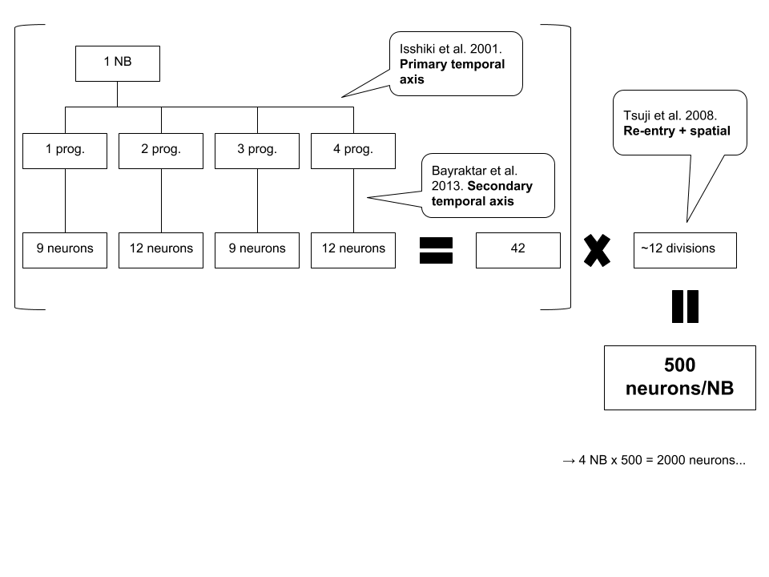So how does this timing come about? An amazing finding was that neuroblasts sequentially express a series of four transcription factors along a **primary time axis** via asymmetric cell division: Hunchback (Hb) 🡪 Seven-up (Svp) 🡪 Krüppel (Kr) 🡪 Pdm1/Pdm2 (Pdm) 🡪 Castor (Cas) (Isshiki, Pearson et al. 2001). Another amazing finding was that a **secondary time axis** exists in which Dichaete 🡪 Grainyhead 🡪 Eyeless transcription factors are serially expressed to produce additional neural subtype diversity (Bayraktar and Doe 2013). Reactivation of neuroblast divisions following quiescence (Tsuji, Hasegawa et al. 2008). Restricted TF expression is due to cross-repressive interactions (Li, Chen et al. 2013). Therefore dual temporal transcription factor sequences control the temporal change of NBs and fate of their progeny.

**Location, location, location…**: Aside from binary fate decisions of cell division that result from temporal patterning on a dual axis, spatial proximity to each other have a role. For example, Tsuji et al. used tandem eagle-Gal4;UAS-GFP crosses and BrdU labeling to identify NB3-3 progenitors (Fig 3 of Tsuji). They found that antp and adb-a, Hox genes, can spatially regulate NB quiescence (Tsuji, Hasegawa et al. 2008).

Figure 1 – Back of the napkin algebra

**References**

Bayraktar, O. A. and C. Q. Doe (2013). "Combinatorial temporal patterning in progenitors expands neural diversity." Nature **498**(7455): 449-455.

Isshiki, T., B. Pearson, S. Holbrook and C. Q. Doe (2001). "Drosophila neuroblasts sequentially express transcription factors which specify the temporal identity of their neuronal progeny." Cell **106**(4): 511-521.

Ito, K. and Y. Hotta (1992). "Proliferation pattern of postembryonic neuroblasts in the brain of Drosophila melanogaster." Dev Biol **149**(1): 134-148.

Lee, T., A. Lee and L. Luo (1999). "Development of the Drosophila mushroom bodies: sequential generation of three distinct types of neurons from a neuroblast." Development **126**(18): 4065-4076.

Li, X., Z. Chen and C. Desplan (2013). "Temporal patterning of neural progenitors in Drosophila." Curr Top Dev Biol **105**: 69-96.

Tsuji, T., E. Hasegawa and T. Isshiki (2008). "Neuroblast entry into quiescence is regulated intrinsically by the combined action of spatial Hox proteins and temporal identity factors." Development **135**(23): 3859-3869.

White, K. and D. R. Kankel (1978). "Patterns of cell division and cell movement in the formation of the imaginal nervous system in Drosophila melanogaster." Dev Biol **65**(2): 296-321.

Zhu, S., A. S. Chiang and T. Lee (2003). "Development of the Drosophila mushroom bodies: elaboration, remodeling and spatial organization of dendrites in the calyx." Development **130**(12): 2603-2610.